**Grocery Chain Inventory Management System**

Application in Python

**Group 16**

Nethra Narayanan

Pratyusha Yellapragada

+1 (747) 299 – 5233

+1 (602) 760 – 8375

narayanan.ne@northeastern.edu

yellapragada.p@northeastern.edu

**Percentage of effort contributed by Student1: 50%**

**Percentage of effort contributed by Student2: 50%**

**Signature of Student 1: Nethra Narayanan**

**Signature of Student 2: Pratyusha Yellapragada**

**Submission Date: 26th Novemeber 2022**

Connection to MySQL from Python

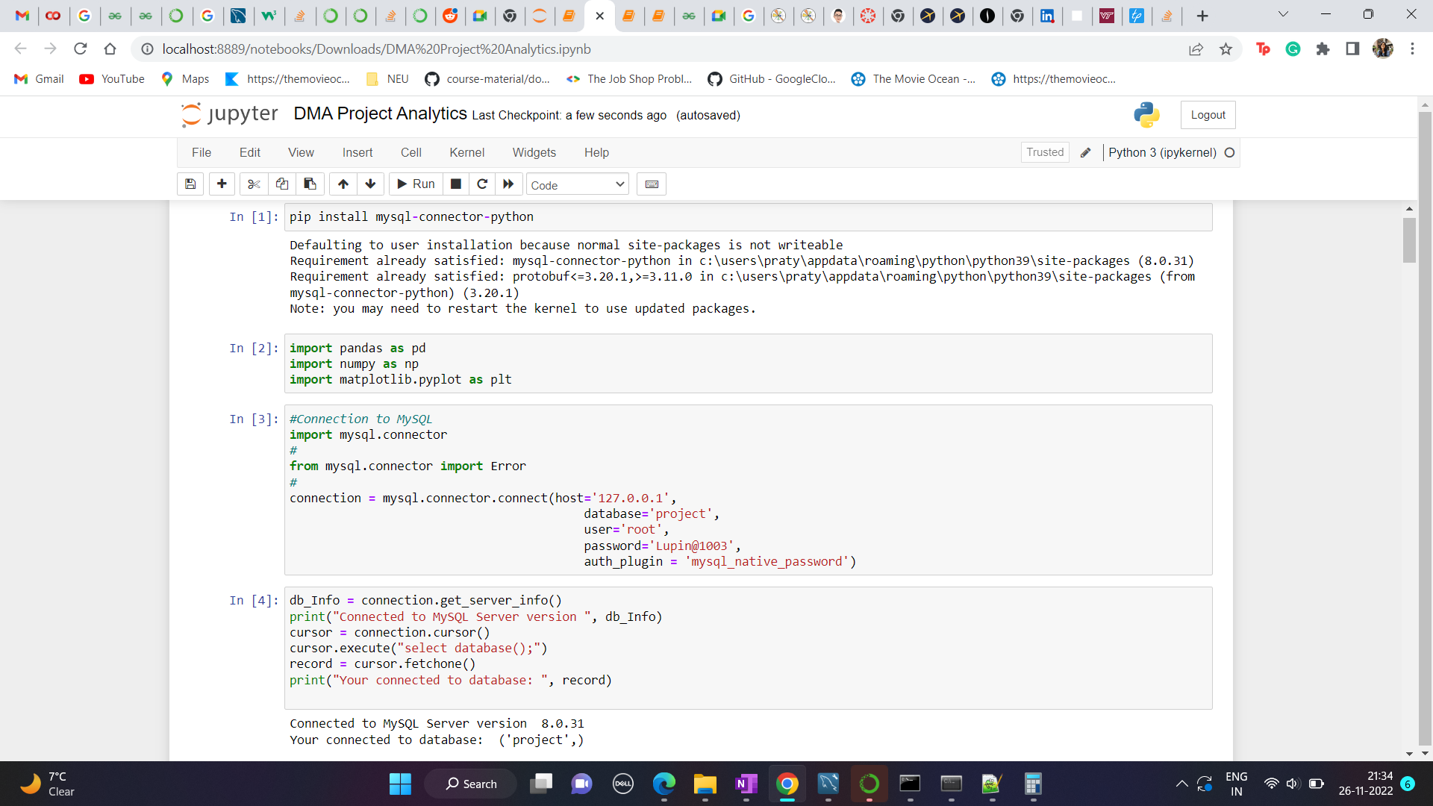

Query to retrive all the managers with nested query and query to retirve ages of employees from date of birth

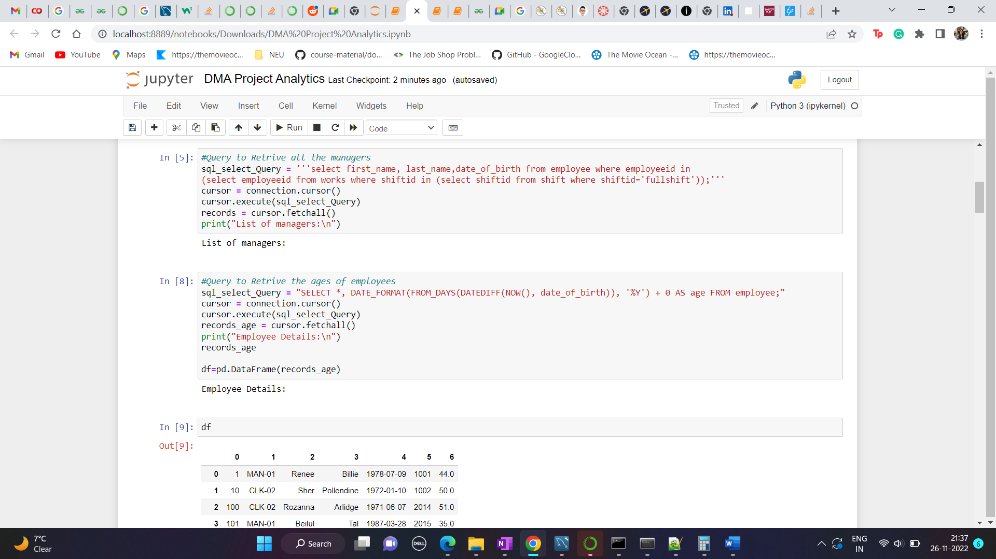

Conversion to Dataframe for ease

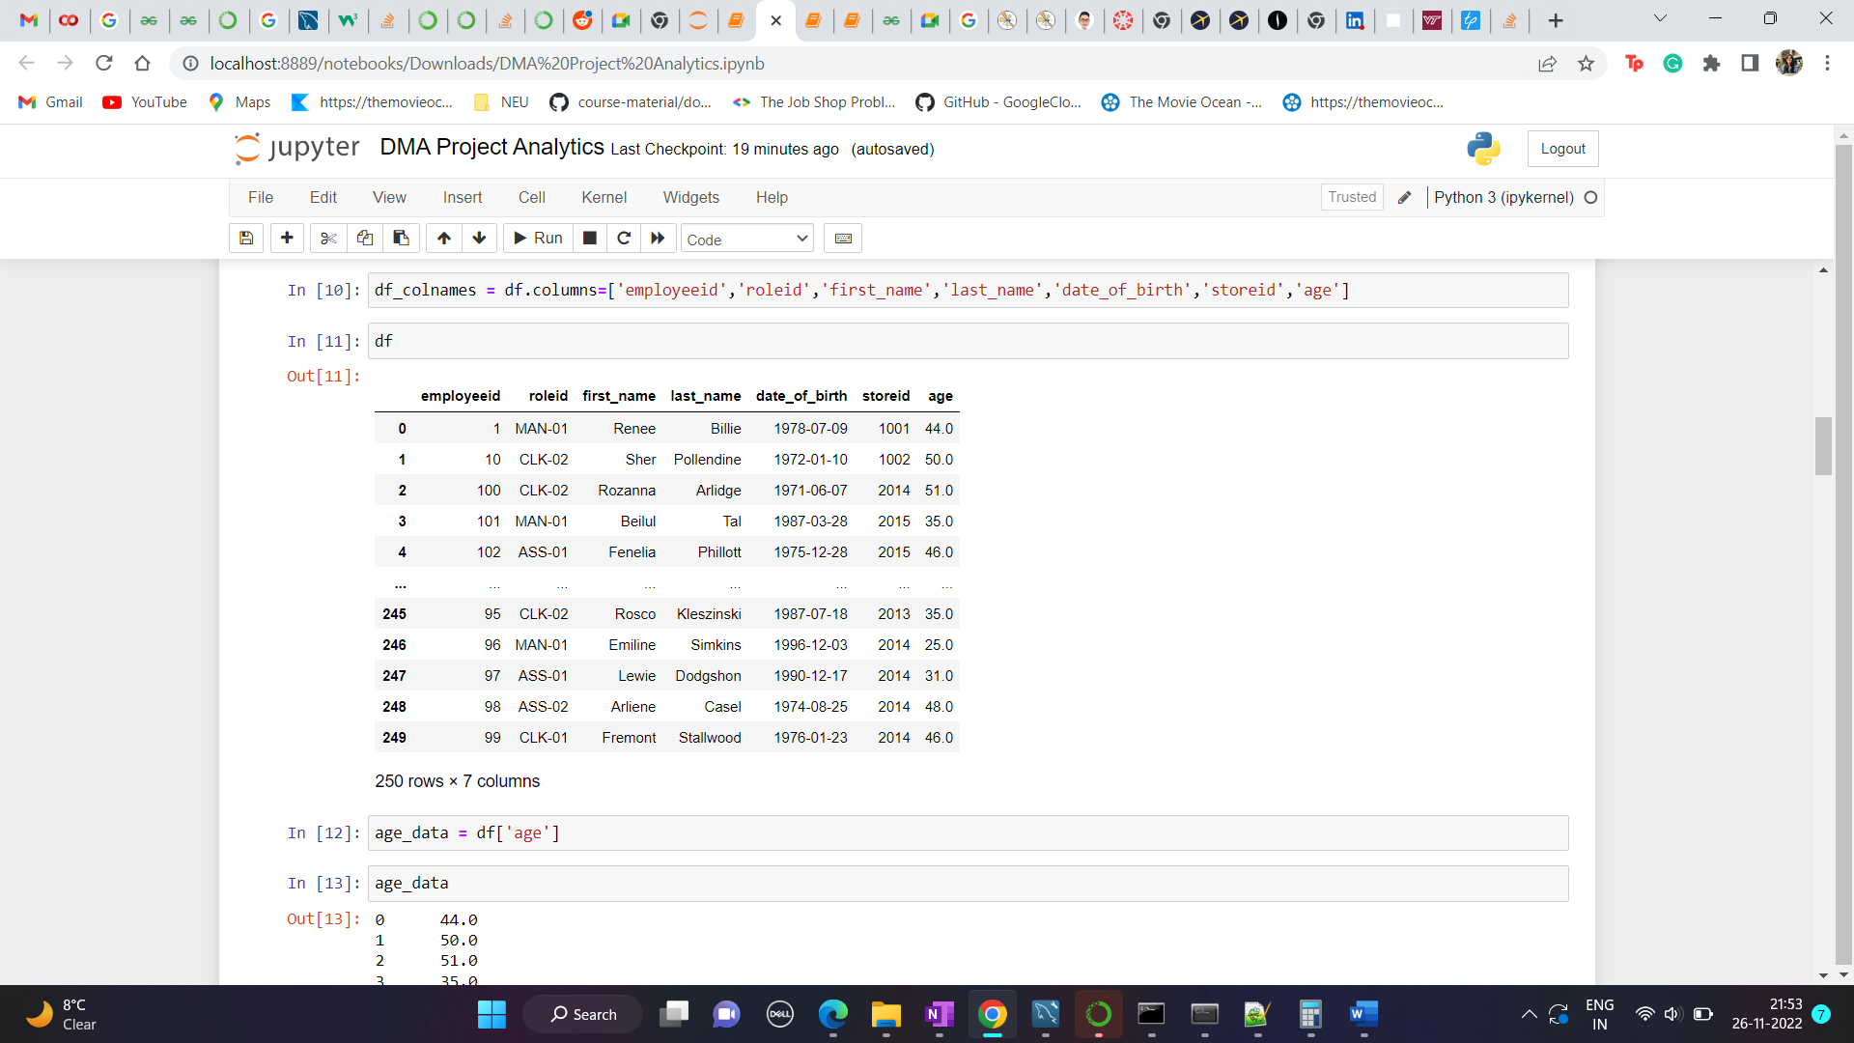

Plot of Frequency Distribution of Employee Age using Histogram

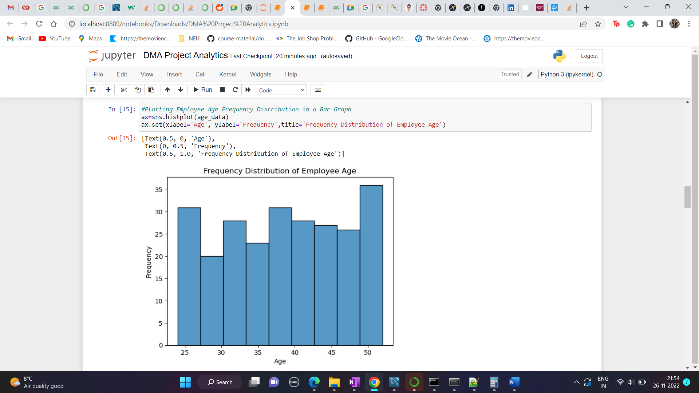

Plot of Frequency Distrinution of Employee Age using Pie Chart

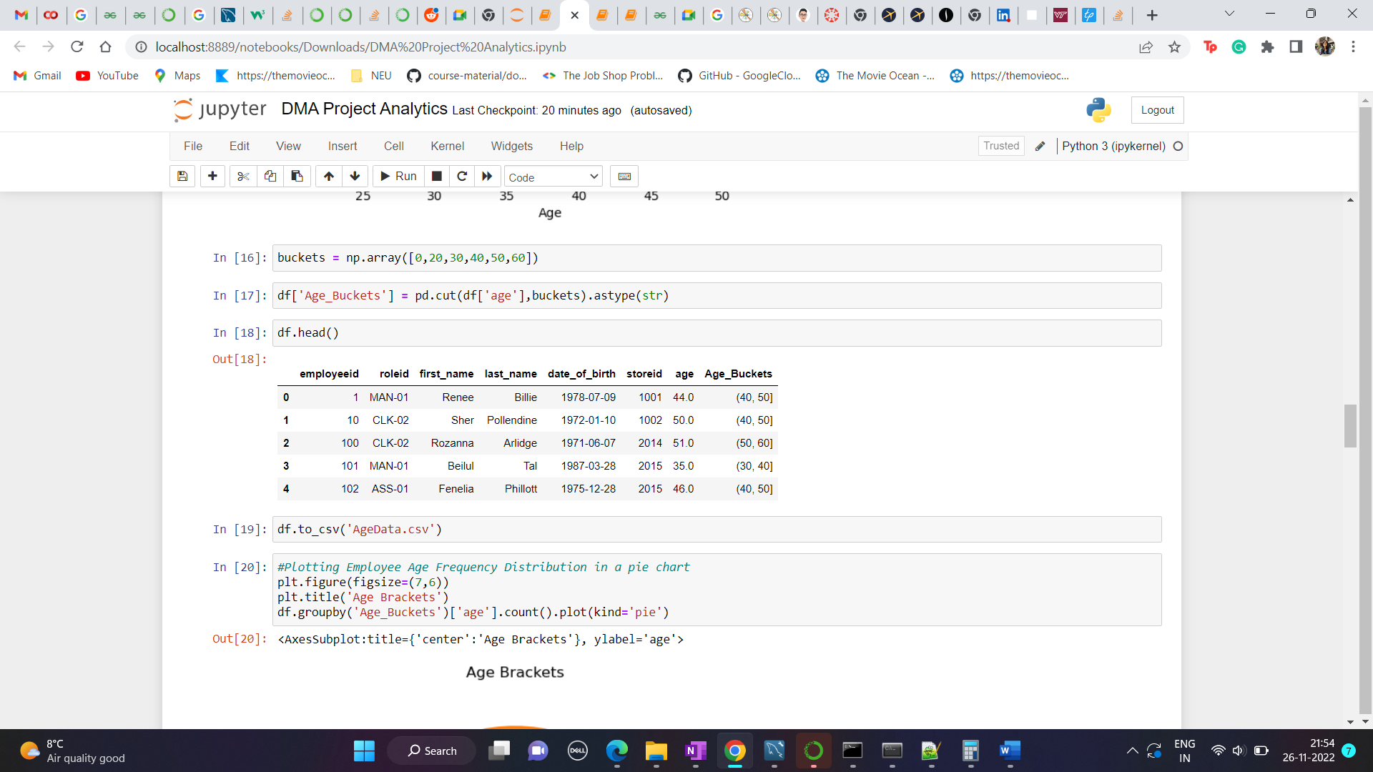

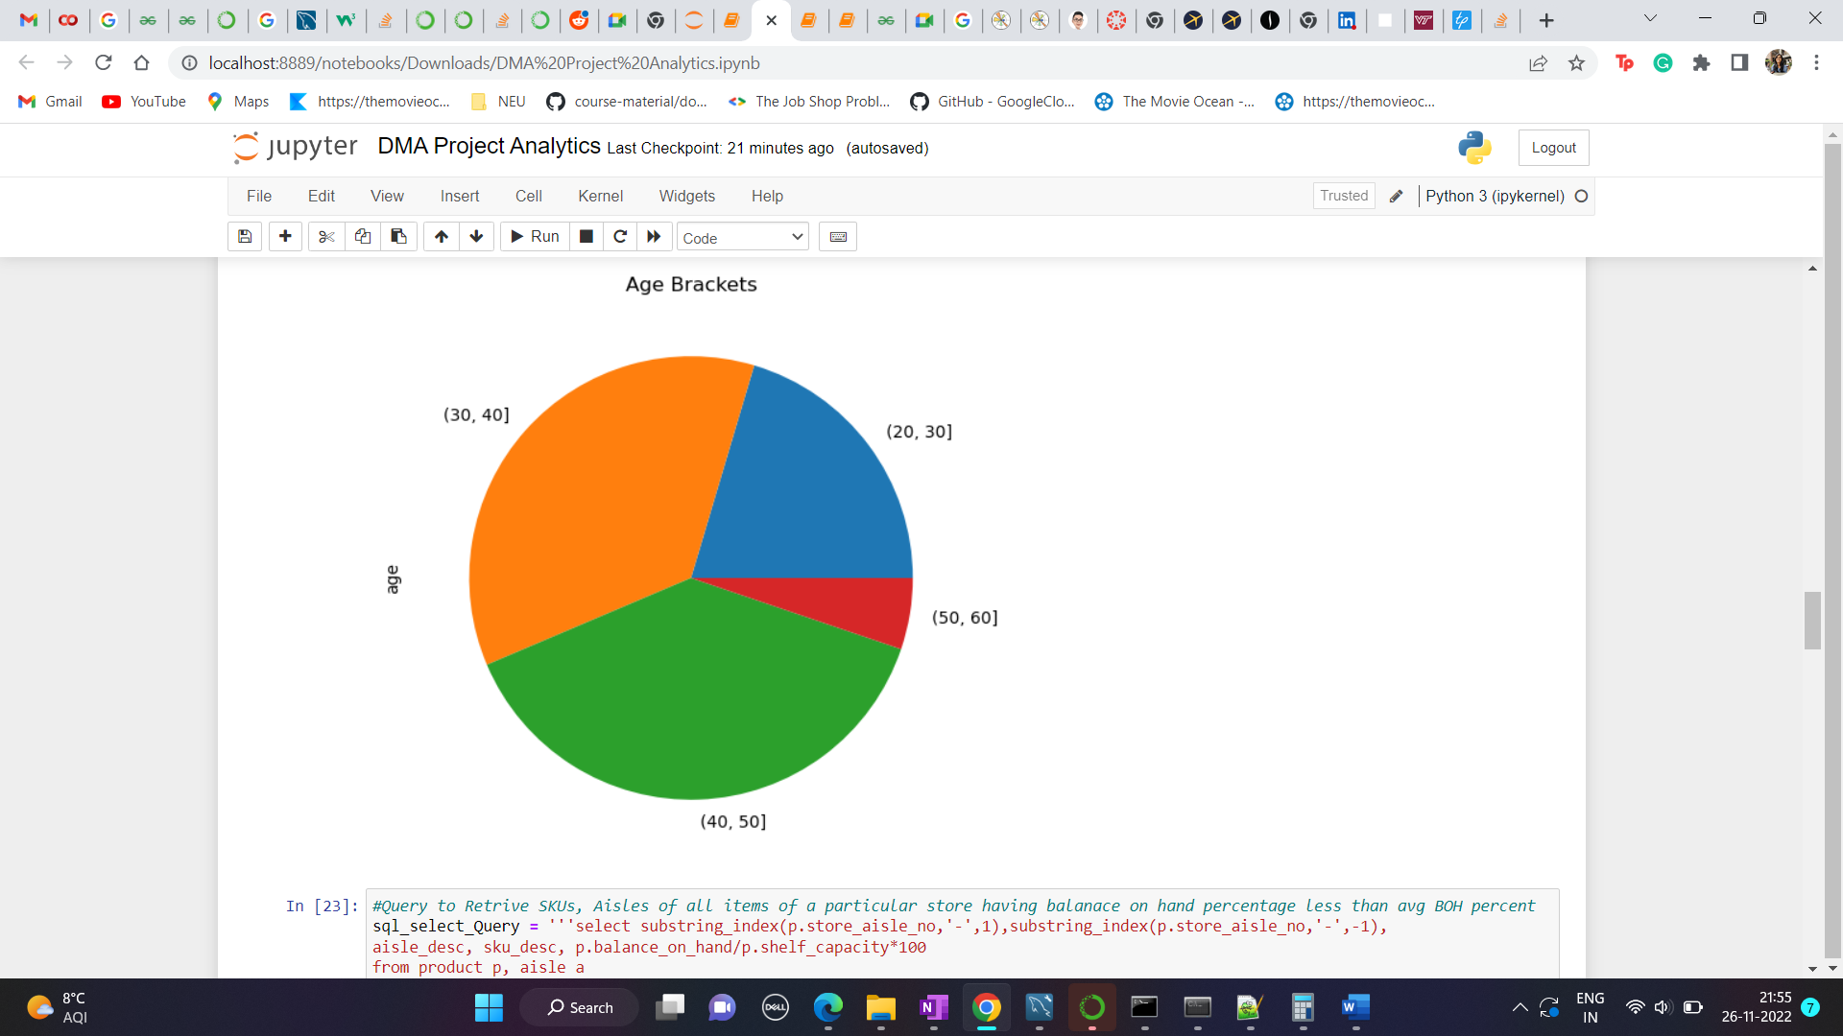

Query to retrive SKUs, Aisles of all items of a particular store having balance on hand percentage less than avg balance on hand percentage using aggregate function, string function and nested queries

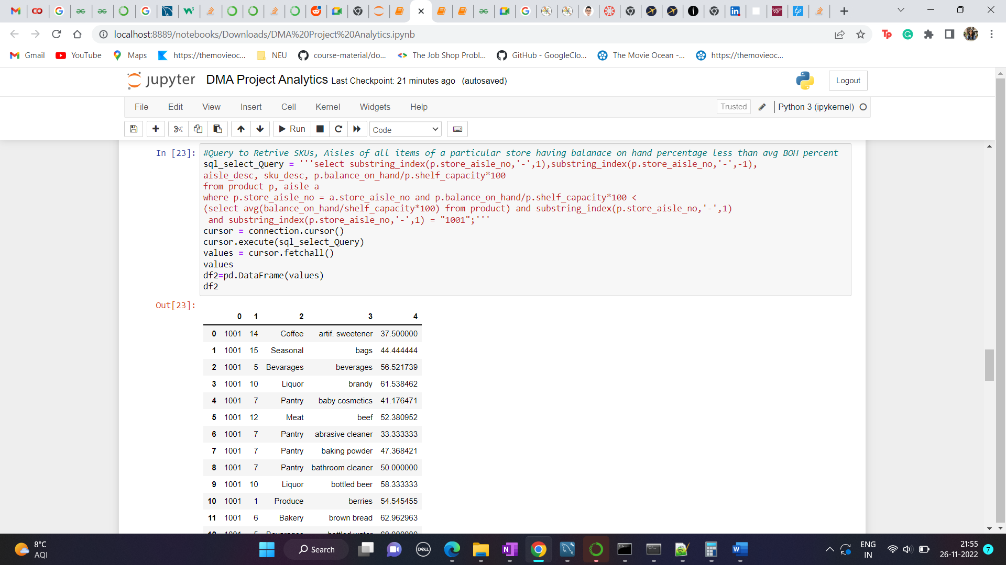

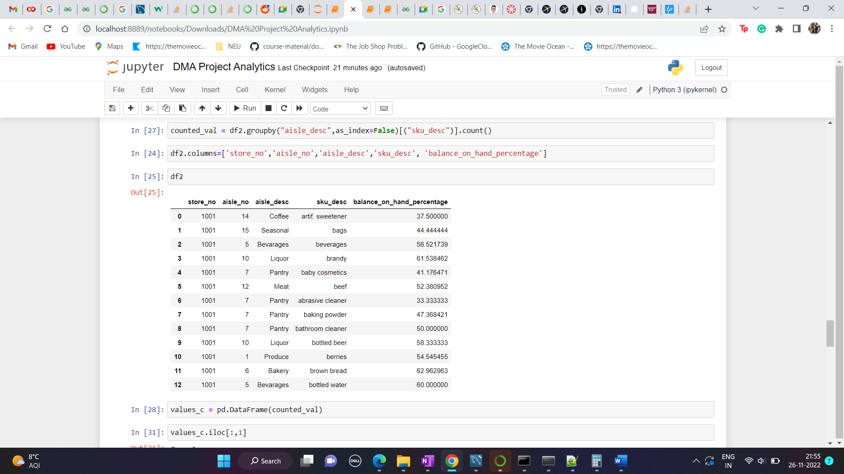

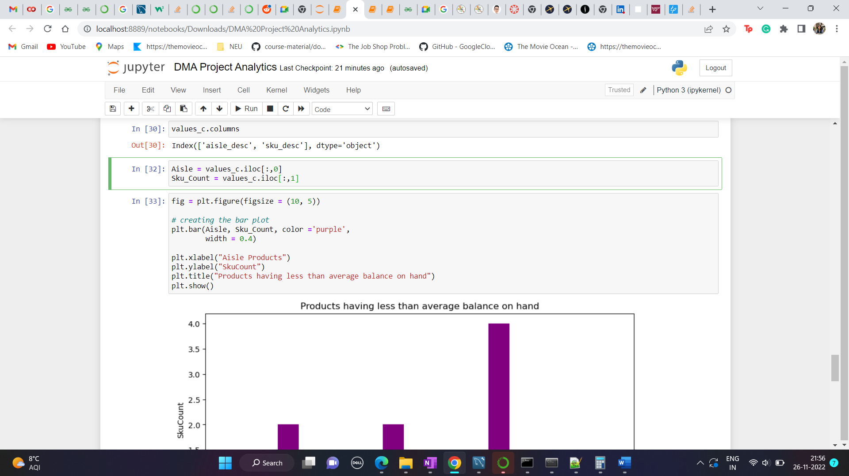

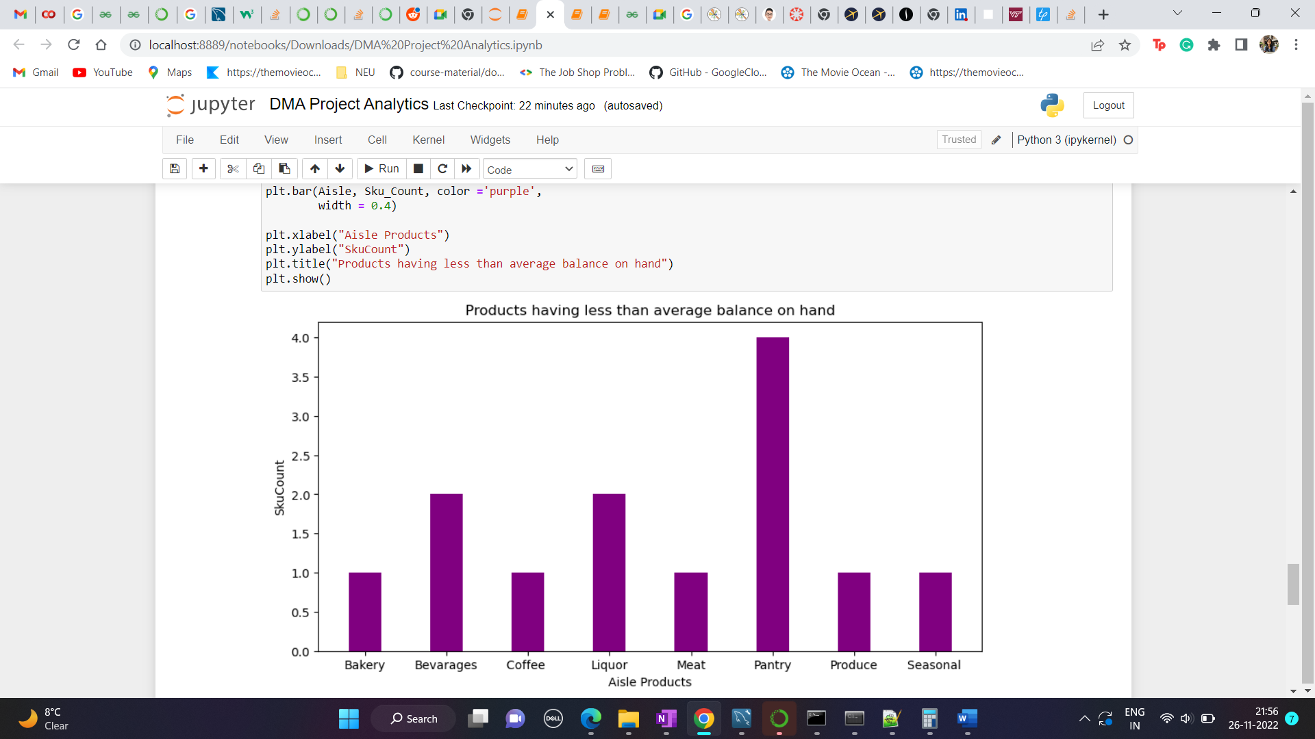

Query to Retrive time difference between order datetime, dispatch datetime and delivery date time

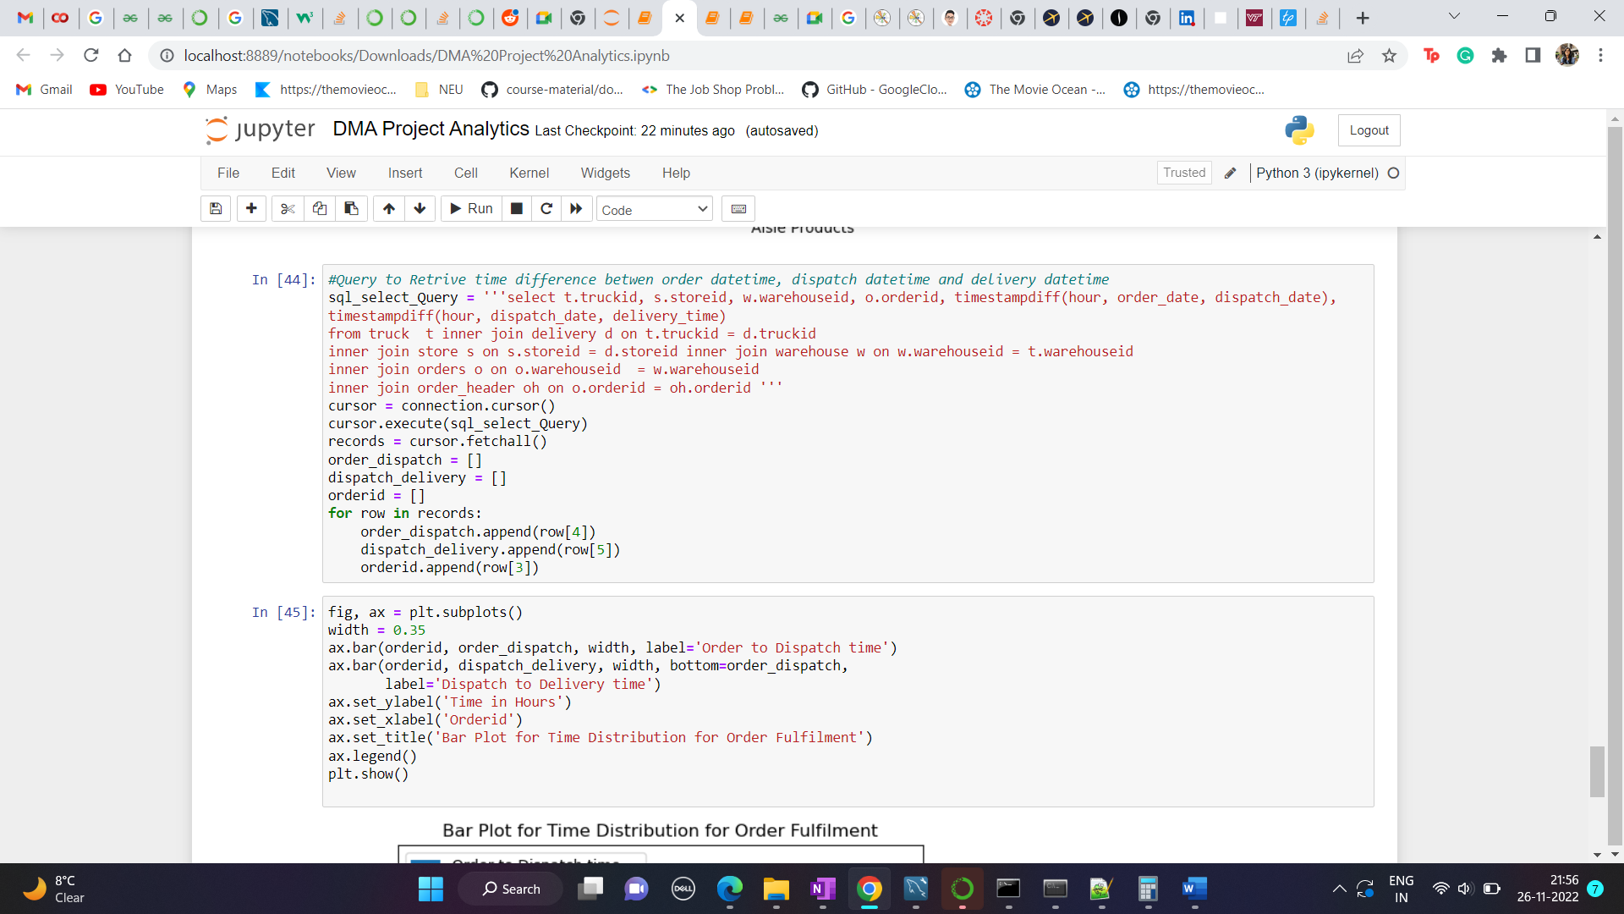

Stacked bar plot of Time Distribution for Order Fulfilment

